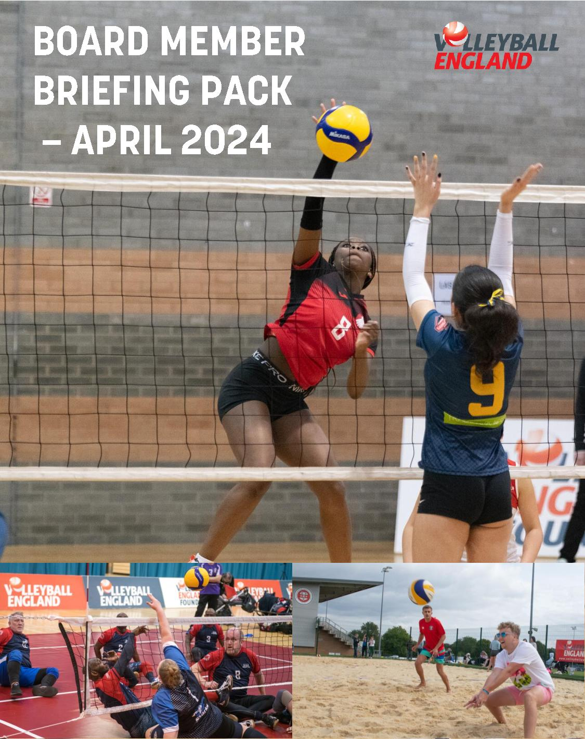

Contents

1 - About Volleyball England 3

2 - Why join the Volleyball England Board? 4

3 - How to Apply 6

4 - Role Description – Board member 7

5 - Person specification 10

6 - Application Form 12

7 - Equality Monitoring Form 16

About Volleyball England
Volleyball England is the recognised National Governing Body for volleyball, beach volleyball and sitting volleyball in England. Volleyball England is responsible for the development, promotion and delivery of volleyball across England.

At Volleyball England, our purpose is to lead the growth and improvement of all disciplines of volleyball in England.

Through connecting the sport at all levels and leveraging its strengths, our vision is to ensure that everyone in the sport feels a sense of belonging.

To help us to achieve our purpose, we will adopt five core guiding principles. These represent ways of working that will influence every decision we make in pursuit of these strategic priorities. As an organisation, these guiding principles commit us to act as follows:

- Our people, diversity & inclusion will be at the heart of everything we do, influencing every decision we make and the way in which we conduct ourselves.

- We will act decisively and transparently, having listened to our customers and stakeholders and made best use of all the evidence and insights available to us.

- We will embrace a culture of continuous improvement, constructively challenging the status quo at all times.

- As a modern and progressive organisation, we will look to incorporate new ideas and technology into everything we do.

- We will operate on a commercially sustainable basis, delivering financially viable products and services. We will spend our time and money wisely, investing in quality over quantity.

And finally, underpinning all of this, we have our five values; connected, innovative, inclusive, respectful and open. These are not just our organisational values. We believe that these are the values which should characterise every single volleyball-related relationship or interaction across our entire community; something that transcends geography, competition, ability or disciplines.

Why join the volleyball england board?
Volleyball England’s strategy is called the Game Plan It’s an ambitious 10-year strategy, which represents a shift in direction as Volleyball England looks to move the sport forward working collaboratively with clubs and members.
At the heart of the Game Plan are three priorities:
- Volleyball for Life - We aim to better understand, articulate and promote the opportunities that volleyball provides for anyone, at any stage of their life.
- Get. Keep. Grow – We will look to strengthen the English volleyball club structure by working hand in hand with clubs to help them achieve their ambitions.
- An Ace Service – We will work collaboratively to deliver and continuously improve the products and services that most benefit our clubs and the wider volleyball community, while also ensuring they provide healthy revenue streams that enable reinvestment in the sport.
Now has never been a more exciting time to join the Sport and contribute to this journey as part of the Board whose primary role is to provide strategic direction and leadership to Volleyball England.
The Board is made up of (up to 12) volunteer Directors with a mix of skills and experience but with a common aim and passion to develop the sport of volleyball within England. In accordance with the Code for Sports Governance Board roles have a maximum term limit which gives us the opportunity to refresh Board roles on a rotating basis.
To help us achieve our strategy we are actively looking for dedicated and passionate individuals who can help Volleyball England achieve its strategic objectives.
We want to develop a Board from a diverse group of people with a wide range of skills, experience, and knowledge. In particular, we are looking for people with skills in Safeguarding, Legal & corporate governance, external sporting context and relationship management. Prior experience is always welcome but it is not essential – we are looking for committed individuals that share our vision and passion for sport at all levels.
In line with our emerging Diversity & Inclusion Action Plan (DIAP), Articles of Association and the Code for Sports Governance, we are committed to increasing the level of diversity throughout the organisation. Whereas we welcome applications from people from all backgrounds that meet the person specification and have relevant experience, we are encouraging interest from underrepresented groups on our board which currently includes those from ethnically diverse communities, members of the LGBTQIA+ community, people with disabilities and females.
Volunteering on a Board can be daunting, and we will provide the relevant support and structures to help the successful candidates succeed. It is a great opportunity to be involved in the sport but also for your own personal and professional development.
If you want to know more – please do contact us at the details below or reach out to any of our current Board members who would be happy to share their experience.

how to apply
Applications to the role of Board Member from individuals with a passion for sport and leadership skills would be welcomed.
Candidates are asked to apply electronically by completing the application form (set out in section 6 below) and returning it with a short CV, giving evidence of how their experience matches the requirements of the role. Applications should be submitted by Monday 6th May 2024. Please also complete the Equalities Monitoring Form (set out in section 7 below) and return at the same time as your application.
The Volleyball England Board has two types of Director (in compliance with its Articles and the Sport England Code for Sports Governance) - Independent Directors (which are individuals that are free from any close connection to the organisation) and Elected Directors (who must be or become members of Volleyball England and are voted in at the organisation’s AGM from a Board recommendation). In your application you will be asked to confirm whether you are eligible as an Independent and/or an Elected Director and the Nominations Committee will consider applications accordingly for the vacancies we have.
Volleyball England is currently looking to recruit 2 x Elected Directors and 1 x Independent Director.
Following receipt of applications, they will be reviewed by the Nominations Committee and those shortlisted will be invited to attend a virtual interview week commencing the 13th May 2024 with the panel to discuss their application and what the Candidate feels they can bring to the role.
Following interviews the Nominations Committee shall make recommendations to the Board for appointment of Directors. Elected Directors will then be put forward for election at the Volleyball England AGM held on Saturday 22nd June 2024. All appointments will take effect from the date of the AGM.
For further information or to request an informal chat, please email governance@volleyballengland.org and you will be contacted by a member of our Nominations Committee.
Completed Application should be returned electronically to: governance@volleyballengland.org.
More information on Volleyball England is available at: www.volleyballengland.org

role description – BOARD MEMBER
The role of a Board member is to support Volleyball England with its strategic direction and implementation of the strategy. We have detailed below some of the specific role requirements. Each Board member works alongside the Volleyball England executive team and Hub staff to provide strategic direction to the organisation in a number of key areas.
Depending on the skills and experience of the successful candidate we will work with the relevant Board member to ensure that there is a good mix of involvement in relevant Sub-Groups and/or initiatives that maximise use of those skills and provide development opportunities for the individual.
Area | Responsibilities of Director
Strategy | - Contribute to effective Board performance and strategy  - Challenge and contribute to the development of strategy constructively  - Support the implementation and development of the Game Plan  - Assist the organisation with setting strategic goals and ensuring that effective monitoring is in place to evaluate progress in achieving key outcomes  - Scrutinise the performance of management in meeting agreed goals and objectives and monitor the reporting of performance  - Support business development, fundraising and development of partnerships  - Ensure that the objectives of the Company, as agreed by the Board, are fully, promptly and properly carried out
Board meetings | - Attend all Board meetings called during the year, unless prevented by exceptional circumstances  - Attend the Annual General Meeting and such other Extraordinary General Meetings as may be necessary  - Play a full part in enabling the Board to arrive at balanced and objective decisions in the performance of its agreed role and functions  - Place on the agenda for meetings of the Board or Sub-Groups of the Board any matter relating to the Company's business, which the Director considers should be discussed  - Ensure that the decisions of the Board are fully, promptly and properly carried out  - Provide robust and sound financial management, ensuring expenditure is in line with the organisations aims and objectives  - Satisfy him/her-self that the integrity of financial information and that financial controls and systems of risk management are robust and defensible.  Board meetings are held in a central location (often Loughborough). During the pandemic these have been held virtually and it is anticipated a hybrid model of virtual and in-person meetings going forward.
Sub-Groups | - Act as a member of such Sub-Groups of the Board as the Board shall decide, attending all meetings of such Subgroups unless prevented by exceptional circumstances.  - Provide support and guidance to Sub-Groups and Working Groups on an ongoing basis to help ensure alignment with the Game Plan
General | - Use such personal and professional skills together with such contacts, experience and judgement as they may possess with integrity and independence to optimise both the short and long term performance of the Company and in particular the areas of her/his areas of responsibility  - Represent the organisation by attending events and external meeting when appropriate.  - Ensure that s/he fully understands: i) the business of the Company and its services; ii) the sport and territories in which the Company operates; iii) the roles of staff in the Company; and iv) the Company's organisation, structure and methods of working;  - Ensure that s/he understands the views of major funding partners, stakeholders and sponsors  - Seek continually to develop and refresh knowledge and skills to ensure any contribution to the Board remains informed and relevant
Fiduciary duties | - Act as a Director of the English Volleyball Association Ltd (t/a Volleyball England) in the best interests of the Company with honesty and good faith towards its members, employees, partners, funding agencies, sponsors and of the communities within which the Company operates  - Ensure strong governance and comply with legislative and regulatory requirements and act within the confines of Volleyball England’s governing documents  - Ensure that s/he complies with all his/her obligations as a Director required by law, the Company's Articles of Association, and decisions of the General Meetings  - Disclose immediately any personal interest in any activity of the Company and take no further part in any Board or Commission/Committee discussion of the matter

All Board member positions are non-salaried. Relevant expenses e.g. travel costs will be payable where appropriate for Board members on official Volleyball England business.
There are maximum term limits for Directors. These are:
- Independent Directors – 4 consecutive terms of 2 years each; and
- Elected Directors – 2 consecutive terms of 4 years each.
In terms of the indicative time commitment, then Candidates should consider the following:
- Induction training (½ day).
- Attendance at and preparation for at least four Board meetings annually (up to ½ day). The Board currently holds its meetings at the weekends.
- Membership of a Sub-Group and/or various committees with regular meetings throughout the year.
- Ad hoc support with specific projects or initiatives as and when required.

Person specification
We are looking for passionate individuals who can help Volleyball England achieve its strategic objectives. The key skills, experience and qualifications required are set out below. We are open to discussing development needs and support required with candidates who have the passion, drive and energy and learn and grow within the role.
Area | Skills and competencies required
Key skillsets | - Results-focused - understands what is important to staff, members and funders - is committed to achieving goals. Tenacious approach to the delivery of quality outputs  - Excellent communication and interpersonal skills - handles complex and difficult situations with thought and confidence  - To have strong intellectual and analytical abilities; be an innovative thinker and ability to focus on the issues to be dealt with  - Strong interpersonal, communication and negotiation skills and the ability to develop effective, sustainable partnerships  - An ability to work effectively as a member of a team and to take decisions for the good of the volleyball community.  - Dynamic, enthusiastic and energetic  - Resilience and ability to make things happen  - To act morally and ethically in accordance with the values of Volleyball England;
Behavioural competencies | - Have a commitment to the purpose, mission, and values of Volleyball England;  - Have an awareness, understanding, and appreciation the needs of the Volleyball England membership  - To maintain a strategic perspective, vision and ability to work positively within a team  - Drive and commitment and the ability to demonstrate this to others  - Selflessness, integrity, objectivity, accountability, openness, honesty and leadership  - To understand the need to base decisions on what is good for Volleyball England  - To accept accountability for group decisions so that the Board of Directors speaks with one voice  - Takes responsibility for your own actions and visibly supports the Executive team and our shared priorities  - To avoid conflicts of interest  - To dedicate sufficient time each week to your board work  - To be able to maintain confidentiality
Key skills, experience/ qualifications of individuals | - An understanding and acceptance of the legal duties, responsibilities and liabilities of a Company Director  - A proven track record of success as a key organisational player significantly involved in delivering strategic objectives  - Experience of running and developing a business or working on a Board or similar forums at a senior level, in a commercial, academic, voluntary or public sector context  - A sound working knowledge of sport and the public and private sectors  - Ability to build and maintain strong, transparent relationships with key stakeholders  - Ability to support, challenge and manage a relationship with other Directors, Sub-Group/Committee Members and Staff
Skills required of Board as a whole (individual directors will each contribute to these but aren’t expected to excel in all) | - Previous board experience  - Financial understanding  - Business management/planning  - Project management  - Sports management  - Strategic planning  - Commercial development/rights exploitation  - Training, HR and Legal  - Working with the voluntary, public and education sector  - Fundraising/income generation  - Data and insight skills  - Partnership working  - Communication skills  - IT skills (software and development/programming)  - Health and safety  - Safeguarding  - Marketing and PR  - Communications  - Campaigning  - Customer Care  - Advocating skills  - Change management  - Conflict resolution  - People management  - Relationship management

application form – board of directors
Full Name
Address & Postcode
Mobile Phone
Email Address
Position applying for

- Employment
Please give details of your career history:

Employer | Position & Responsibilities | From | To

- Please state why you wish to join the Board of Volleyball England, and what you feel you could bring to the role:

- Relevant Skills, knowledge and experience.
Please refer to the role description and person specification provided and describe how your knowledge and expertise meets our requirements for this post.

- Are you currently, or have you been a Non-Executive Director, Director/Officer or Trustee of any organisation within the last five years? If so, please give details:

- What is your current employment or profession?

- Are you a member of any professional bodies, institutes or societies?

- Please use the space below to provide a personal statement or any further information in support of your application.

- Have you ever been disqualified as a Director or Trustee of any other organisation?

☐ Yes ☐ No
If yes, please provide details:

- Additional information – tell us about your hobbies and interests:

- Independent or Elected Director – please confirm whether you are eligible to apply for Independent and/or Elected Director.

To apply to be an Independent Director you must be free from any close connection to the organisation and if, from the perspective of an objective outsider, they would be viewed as independent. A person may still be deemed to be ‘independent’ even if they are a member of the organisation and/or play the sport.

Examples of a ‘close connection’ include: (A) they are or have within the last four years been actively involved in the organisation’s affairs, e.g. as a representative of a specific interest group within the organisation such as a sporting discipline, a region or a home country, sub-group or working group; (B) they are or have within the last four years been an employee of the organisation; or (C) they have close family ties with any of the organisation’s directors or senior employees.
An Elected Director must be or become a Member of Volleyball England. We generally ask that Elected Directors have excellent volleyball knowledge and commitment to development and success of the sport. Under the Articles of Association to be eligible as a Director the application must be 18 years or older.
All applicants will be interviewed by the Nominations Committee of Volleyball England who are required to operate a competence-based recruitment process. They will make recommendations to the Board and, in respect of Elected Directors, subsequently to the AGM on the candidates which have the skills and capabilities needed by the organisation in the next stage of its journey.

☐ Elected only ☐ Independent ☐ Either

- References
Please give details of two referees:

Name: Click or tap here to enter text.  Address: Click or tap here to enter text.  Relationship to you: Click or tap here to enter text. | Name: Click or tap here to enter text.  Address: Click or tap here to enter text.  Relationship to you: Click or tap here to enter text.

May we approach these people for references without further consultation with you?

☐ Yes ☐ No

Declaration:

I declare that the information I have given in support of my application is, to the best of my knowledge and belief, true and accurate. I understand that if it is found that my statement is false or misleading, or that I withheld relevant information, my application may be disqualified or, if I am already in post, I may be removed from the Board.

I give my consent to the Volleyball England to store and process the information I have given in accordance with the Volleyball England privacy policy – available by clicking here.

Signed: .............................................

Date: ..............................................

Electronic signature is acceptable

equal opportunities monitoring form
We are fully committed to providing equal opportunities for all employees, volunteers workers and job applicants, and to eliminating unlawful and unfair discrimination. We aim to create a culture that encourages and values diversity, and that appoints, rewards and promotes staff based on merit.
Your responses to the questions set out below will be used only to monitor the effectiveness of our policies and practices, and to ensure that we do not inadvertently discriminate against employees or prospective employees because of ethnicity, disability, gender, sexual orientation, age or religion or belief.
The information you give will be kept strictly confidential and will not be seen by the staff and/or volunteers directly involved in the recruitment process for the relevant post. Your response will be detached from your application form on receipt. It will be used only to provide statistics for monitoring purposes and will be stored separately, in accordance with the Volleyball England privacy policy (provided to you as part of the application form) and relevant data protection policies. You do not have to provide this information, but if you do so, it will be helpful for the purposes set out above.
Post being applied for:
Date:
- Ethnicity
How would you describe yourself?
Asian or Asian British
Bangladeshi
Indian
Pakistani
Chinese
Other Asian background (please write in box)
Prefer not to say
Black or Black British
African
Caribbean
Other Black background (please write in box)
Prefer not to say
Other ethnic group
Arab
Other ethnic background (please write in box)
Prefer not to say
Mixed/multiple ethnic groups
White and Asian
White and Black African
White and Black Caribbean
Other mixed/multiple ethnic background (please write in box)
Prefer not to say
White
British
English
Gypsy or Irish traveller
Irish
Northern Irish
Scottish
Welsh
Other white background (please write in box)
Prefer not to say
- Disability
Do you have a disability? | Yes/No
Prefer not to say
This information is used for monitoring purposes only. If you believe you may be disabled and may need any reasonable adjustments to be made in the recruitment process or as part of your role, please do contact us to discuss this.
- Gender
Which of the following best reflects how you would describe your gender identity?
Male
Female
Trans or transgender
Other (please describe, if you are happy to do so)
Prefer not to say
- Does your gender identity align with the gender assigned to you at birth:
Yes
No
Prefer not to say
- Marital status
Married (different sex)
Married (same sex)
Civil partner
Single
Other
Prefer not to say
- Sexual orientation
Would you describe yourself as:
Bisexual
Gay/lesbian
Heterosexual/straight
Other
Prefer not to say
- Age (please highlight)
Under 25 | 25–34 | 35–44 | 45–54 | 55–64 | 65 and over
- Religion and belief
The list below includes those religions that are most commonly found in Britain. They are listed in alphabetical order and not intended to signify rank in terms of importance. This list is not exhaustive; if your religion is not listed then we ask you not to take offence as none was intended.
Please tick the box that best describes your religion or belief:
Buddhism
Christianity
Hinduism
Judaism
Islam
Sikhism
Other religion or belief (please specify)
No religion
Prefer not to say

Thank you for taking the time to complete this monitoring information

In order for us to improve awareness of future opportunities to as wide an audience of potential candidates as possible, please indicate how you found out about this vacancy or where you saw it advertised.

